Pyramid of Plain:
The pyramid of pain is applied to improve the efficiency of CTI and the world-famous companies are using the pyramid of pain like Cisco security, Sentinel One and SOC radar.

Pyramid of Pain is used in Threat Hunter, Incident Response and SOC analyst.

Task2 Hash Values (Trivial):
The hash values are used to uniquely identified the attributes of the files, pictures etc. The hash values are generated by the using the hashing algorithms which were developed by the different cryptographic scholars and professionals.

The hashing algorithm consider more secure when the other have file has not the same value of hashing
MD5 (the message Digest 5):
Gives the 128-bit hash value is widely used cryptographically but it is not considered secure

The SHA-1 (Secure Hash Algorithm): IS invented by the united national security in 1995
160-bit hash value string as a 40-digit hexadecimal number

The SHA-2 (Secure Hash Algorithm): is in created by the national institute of science and technology (NIST) and the national security agency (NSA) to replace the SHA-1.
SHA-2 has different variants and most common is used as SHA-256 returns the hash value of 256-bit as a 64-bit hexa-decimal value.

Note: A hash is not considered cryptographically secure it the 2 files have same hash value or digest.

Security Professional used the hash values for malware insights, uniquely identifies the suspicious files.

Websites: Virus-totals and Meta defender Cloud:

Virus-total:
Url: https://www.virustotal.com/gui/file/01b32400dada222a87a21834ceb8cd7fc95b88da0561711b81e027e8974eede3
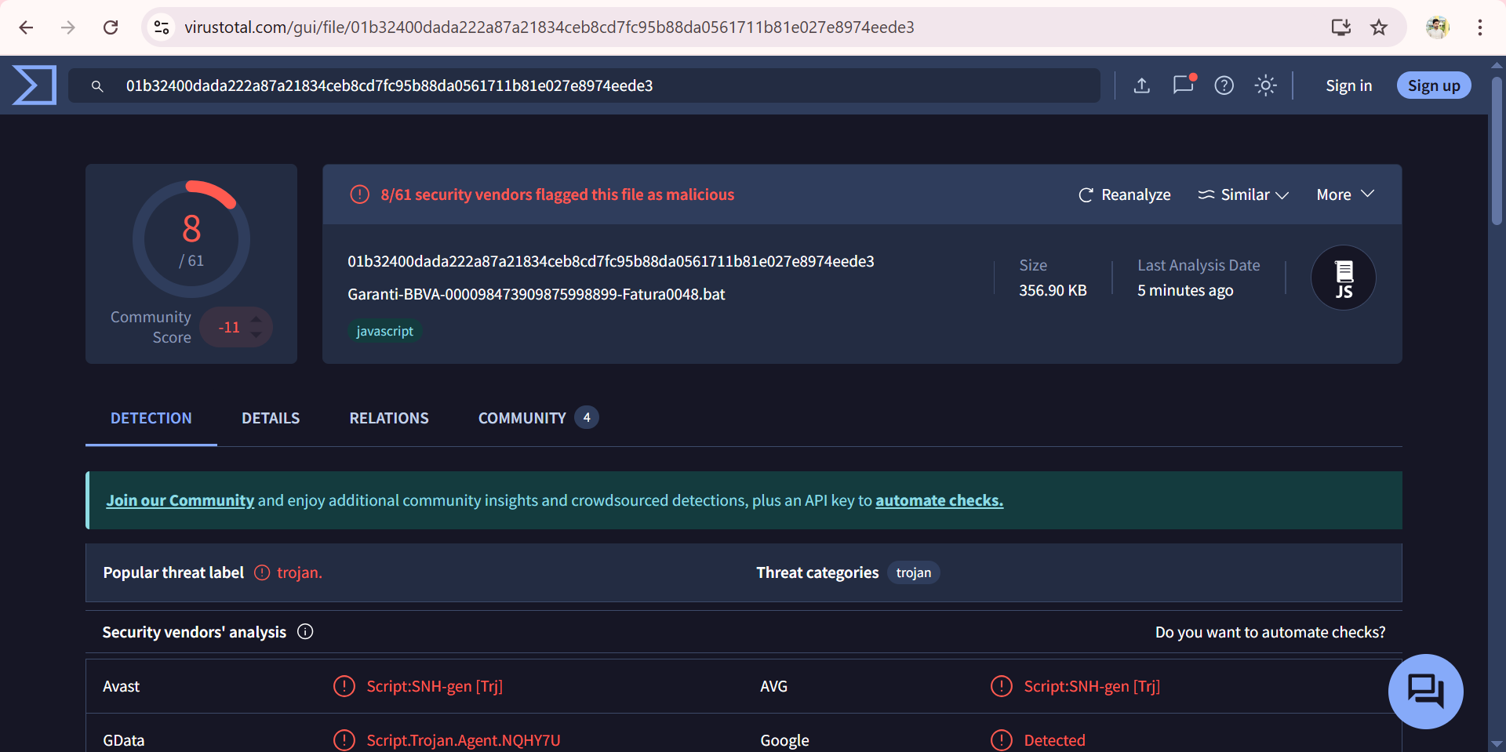

Meta-defender Cloud:
Url: https://metadefender.opswat.com/
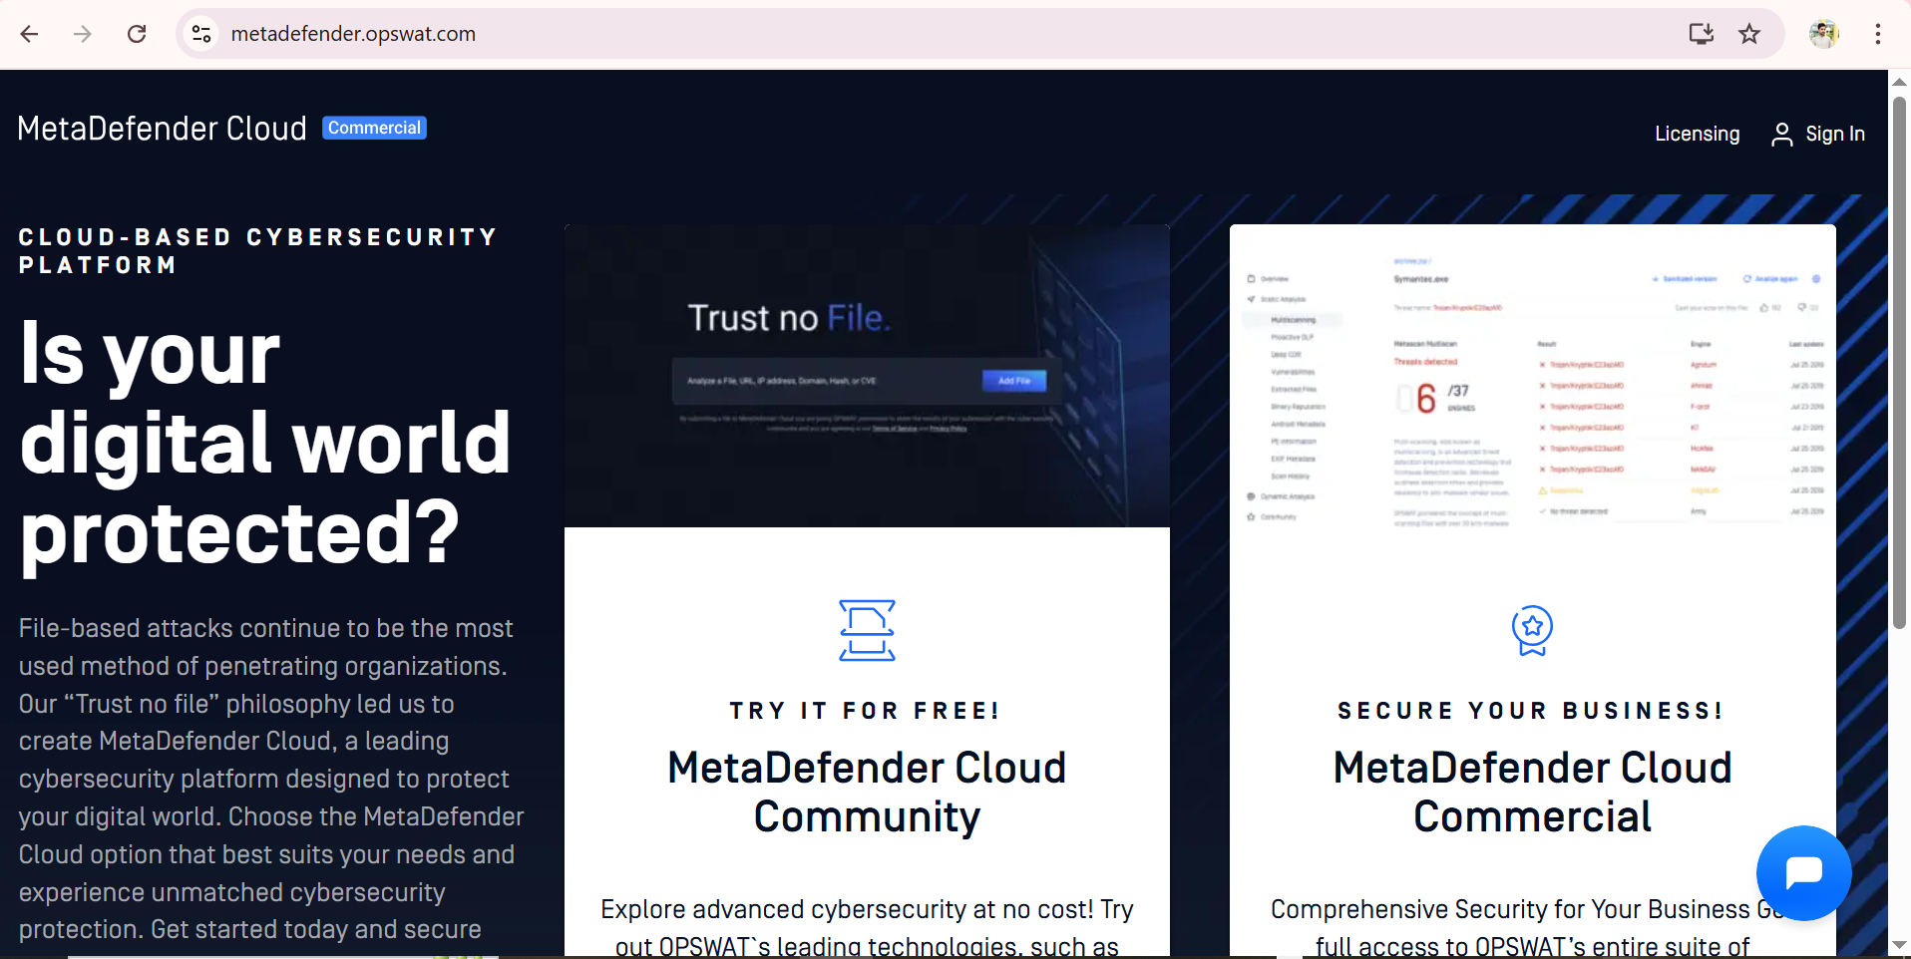

Important note:
If the attacker changes the single bit of file, then its hashing is different and its IOC’s changes which are difficult to detect.

Changing the Hash-value:
Just appending a single string in file, it can change its hash values so the IOCs of the malicious file is changed

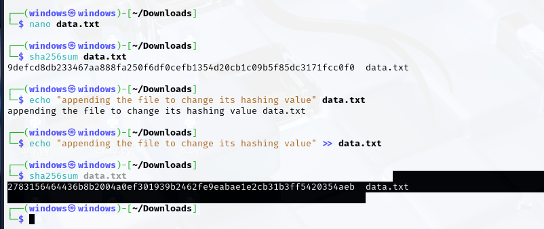

Possible question on the hashing:

Here’s a simplified SOC/Blue Team interview guide based on your scenario.
All answers are written in clear, easy English so you can speak confidently in HR or technical interviews.

⚡ Scenario
Attackers use C2 frameworks (like Cobalt Strike, Mythic, Viper) to control a victim machine.
They keep changing the payload’s hash (by rebuilding or modifying the file) so that hash-based security rules can’t detect it.

🔥 Common Interview Questions with Simple Answers

1️⃣ Hash Evasion Basics
Q1. A Cobalt Strike beacon’s SHA256 hash changes every time. How is this possible?
A1.
Attackers can:
- Recompile the file each time (different compiler settings or build times).
- Use a packer or crypter to wrap or encrypt the file.
- Add random junk data or padding to the file.
- Use polymorphic code that rewrites itself on every build.
All of these create a new hash even if the behavior stays the same.

2️⃣ Droppers & Delivery
Q2. What is a dropper and how does it help bypass hash detection?
A2.
A dropper is a small first-stage file that runs on the victim machine and then downloads or creates the real malware in memory.
Because the final payload is not present on disk at first, security tools cannot hash it before it runs.
The dropper’s hash is different from the final malware.

3️⃣ Beating Hash-Only Security
Q3. How do attackers make hash-based indicators useless?
A3.
- Change the code slightly each time (different builds).
- Use custom packers/cryptors to hide code.
- Inject the payload into memory without writing a file.
- Use legit Windows tools (PowerShell, mshta) to run commands with no malicious file.
- Use fileless malware that runs only in memory or registry.

4️⃣ C2 Framework Tricks
Q4. How do Cobalt Strike malleable profiles make detection hard?
A4.
The attacker can change network settings—like HTTP paths, headers, encryption settings, and timing—so every campaign looks different.
This breaks simple network indicators like fixed URLs or IPs.
Q5. How can Mythic or Viper make each beacon unique?
A5.
They can:
- Change encryption keys each time.
- Change sleep times, user-agents, or watermark IDs.
- Use different paths or servers to download the next stage.

5️⃣ Detection Beyond Hashes
Q6. If hashes keep changing, how can a SOC detect attacks?
A6.
- Look at behavior, not just files:
  - Suspicious parent/child processes (e.g., Word starting PowerShell).
  - PowerShell with Base64 or “-enc” arguments.
- Use memory scanning or YARA rules to find patterns in running processes.
- Watch network traffic:
  - TLS fingerprints (JA3), beaconing patterns, or DNS anomalies.
- Use fuzzy hashing like SSDEEP/TLSH to see if files are similar even if hashes differ.

6️⃣ Advanced
Q7. What is “fileless C2” and why can’t hashes catch it?
A7.
Fileless malware runs entirely in memory (for example PowerShell scripts or .NET assemblies).
No file is saved to disk, so there is no file to hash.
Detection must use memory forensics, PowerShell logs, or event tracing.
Q8. What’s the difference between SHA256 and fuzzy hashing (SSDEEP/TLSH)?
A8.
- SHA256: exact match only—one bit change = totally new hash.
- Fuzzy hashing: gives a similarity score, so you can see if two files are “close” even if not identical.

7️⃣ SOC Response
Q9. You find a suspicious dropper that is not in VirusTotal. What do you do?
A9.
- Isolate the host to stop the attack.
- Capture memory and system artifacts.
- Run the sample in a sandbox to watch its behavior and network traffic.
- Make YARA rules for unique strings or functions.
- Search for network indicators (domains, JA3 fingerprints) across the environment.
Q10. How to detect a Cobalt Strike beacon that changes TLS fingerprints every day?
A10.
- Look for regular beacon timing (same time gaps between connections).
- Monitor for unusual JA3 or JA3S fingerprints.
- Use machine learning or analytics to detect strange traffic patterns.

8️⃣ Red vs. Blue
Q11. If you were the attacker, how would you avoid hash detection?
A11.
Use a combination: packers to change the file, in-memory injection to avoid disk, encrypted C2 over HTTPS, and domain fronting to hide behind trusted domains.
(Explain that you know this only to defend against it.)
Q12. As a defender, what do you focus on when hashes are useless?
A12.
- First watch process behavior,
- then network anomalies,
- then memory evidence.
Combine EDR, Sysmon logs, and threat intelligence for a full picture.

✅ Key Takeaways
Attacker Method | Defender Focus
Change file hashes with packers | Fuzzy hashing, YARA patterns
Encrypt payloads | Inspect TLS/JA3, look for abnormal beacons
Fileless or in-memory execution | Memory scans, PowerShell/ETW logging
Malleable C2 profiles | Beacon timing analysis, domain fronting detection

💡 HR-Friendly Summary
If an interviewer asks “How do hackers bypass hash-based security?”,
you can answer:
“Hackers change their files or run code in memory so the hash never matches.
They also hide their network traffic using encryption or changing profiles.
That’s why SOC teams use behavior analysis, fuzzy hashes, and network monitoring instead of relying only on file hashes.”
This shows clear understanding without deep jargon—perfect for both HR and technical panels.

IP:
The Ip address stand for internet protocol it is mapped on the network layer.(layer-3 of the OSI model). The primary purpose of IP address is to uniquely identified the computer connected to it.
The main concern of the SOC analyst with the ip is that, they detect malicious ips , block , quarantine and dropped the connections from malicious ip that are making connections to our organizations perimeter and external firewall.

But the hacker is stepping a head they used the concept of Fast Flux in which the multiple ip are associated with the single domain make it difficult to detect and stop the malicious activities.
What is fast flux:
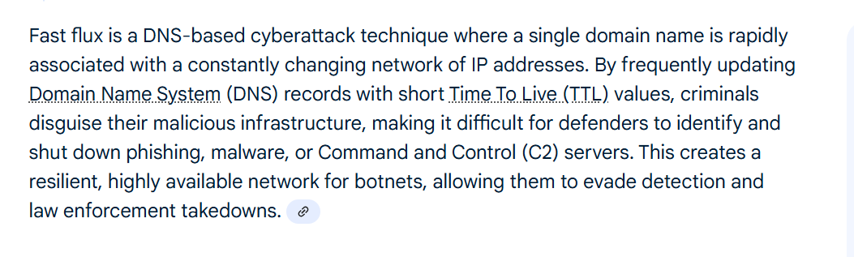

Possible questions on the Fast Flux:
Single flux and double flux:
Here’s a complete SOC interview prep guide for Fast Flux
with difficult and scenario-based questions,
plus clear, easy answers and abstract examples to help you explain the concept to both technical and HR panels.

⚡ Fast Flux Summary (Easy Definition)
Fast Flux is a DNS trick used by attackers (often botnets) to hide their real servers.
One domain name keeps changing its IP addresses every few minutes or seconds.
These IPs belong to infected victim machines (bots) that forward traffic to the attacker’s real Command & Control (C2) server.
Goal: make it hard to block or take down the attacker’s infrastructure.

🔥 Possible Interview Questions & Simple Answers

1️⃣ Concept Basics
Q1. What is Fast Flux in simple words?
A1.
Fast Flux is when one domain name points to many IP addresses that change very quickly.
It’s like changing your house address every few minutes so the police can’t find you.

Q2. Why do attackers use Fast Flux?
A2.
To hide their real servers and keep their malicious websites or C2 servers online even if some IPs are blocked.

Q3. What is the difference between Fast Flux and normal Content Delivery Networks (CDNs)?
A3.
CDNs also use multiple IPs but they are legitimate and have longer TTLs (Time To Live).
Fast Flux changes IPs much faster, uses compromised machines, and is linked to malicious activity.

2️⃣ Types and Patterns
Q4. What are the types of Fast Flux?
A4.
- Single Flux: Only the A records (IP addresses) change rapidly.
- Double Flux: Both A records and NS (Name Server) records change to hide the DNS servers themselves.

Q5. What DNS behavior shows Fast Flux?
A5.
- Very short TTL values (seconds or a few minutes).
- One domain resolving to dozens or hundreds of IPs in a short time.
- IPs often belong to home users or random countries.

3️⃣ Scenario Questions
Q6. Imagine a phishing website that stays online even after you block several IPs. How could Fast Flux explain this?
A6.
The attacker uses many infected machines.
When one IP is blocked, the domain quickly changes to a new IP.
Your block only stops a small part of the network.

Q7. In a SOC alert, you see a domain with 200 IPs in one hour. What steps would you take?
A7.
- Check the TTL value (is it very low?).
- Look for geographically scattered IPs.
- Check threat intelligence feeds for botnet activity.
- Block the domain name itself, not just single IPs.

Q8. Your HR asks: “Why can’t we just block the bad IP addresses?”
A8.
Because the IPs change so quickly, blocking one is like trying to catch a moving car.
It’s better to block the domain name or use detection tools that spot the Fast Flux pattern.

4️⃣ Deep Technical / SOC-Level Questions
Q9. How can you detect Fast Flux using logs or SIEM?
A9.
- Look for DNS queries where:
  - Many different IPs appear for the same domain within a short time.
  - TTL values are unusually low (e.g., 60 seconds).
  - IPs belong to consumer ISPs, not data centers.
- Use tools like Passive DNS, Splunk, or ELK to see changes over time.

Q10. How would you explain Fast Flux to a non-technical manager?
A10.
“It’s like a scammer who keeps moving between hundreds of temporary apartments every few minutes.
Instead of finding the scammer, we track the phone number (the domain) because the address keeps changing.”

Q11. If a botnet uses Double Flux, what extra challenge does it create?
A11.
Double Flux hides not just the servers but also the DNS name servers.
Even if you try to block the DNS servers, they change too.

Q12. What is the relationship between Fast Flux and botnets?
A12.
Fast Flux uses infected machines in a botnet to act as reverse proxies.
These bots hide the real C2 server by forwarding the traffic.

5️⃣ Example Abstract Scenario (to explain in interviews)
Imagine you are playing a game of “tag” where:
- The attacker is hiding in a house.
- Every minute, the attacker switches houses among hundreds of friends’ homes (bots).
- The door sign (domain name) stays the same, but the house address (IP) keeps changing.
This is Fast Flux.

✅ Possible Solutions / Defenses
Method | Simple Explanation
Domain blocking | Block the domain name instead of chasing each IP.
Passive DNS analysis | Track how often a domain changes IPs.
Low TTL monitoring | Flag domains with very short TTLs.
Threat intel feeds | Use updated lists of known Fast Flux domains.
Sinkholing | Take over the domain if law enforcement allows.
EDR/Network monitoring | Detect unusual outbound traffic from infected hosts.

💡 HR-Friendly Answer Template
If HR asks: “How do we defend against Fast Flux?”
You can say:
“We focus on detecting the pattern, not individual IPs.
We monitor DNS for rapid IP changes, block suspicious domains, and share intelligence with ISPs and law enforcement to take down the malicious network.”

🔑 Key Takeaways
- Fast Flux is about changing IPs quickly to hide attackers.
- Blocking single IPs is not enough—block the domain and watch DNS behavior.
- Tools like Passive DNS and SIEM correlation are essential for detection.
This approach lets you explain clearly to HR and still show technical depth to a SOC panel.

Double flux:

Any.Run:
url: https://app.any.run/submissions

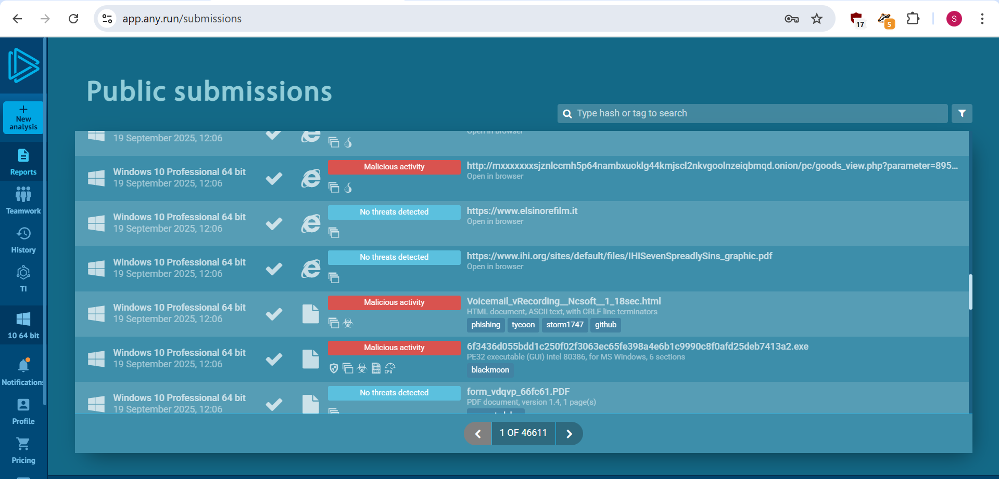

Great question ✅—and this is exactly the kind of “what if” an interviewer (or a real SOC lead) will test you with.
Let’s break it down carefully:

1️⃣ If You Block the Domain Name (the “Front Door”)
- Example: You add a rule in your IDS/IPS or firewall to block malicious-example.com.
- ✅ Effectiveness:
  - Yes, this will stop all traffic that still tries to resolve or reach that domain.
  - Even if the attacker keeps changing IP addresses (A records) or name servers (NS records),
the firewall will drop it because the name itself is on the blacklist.
👉 Key Point:
Double Flux depends on keeping one stable domain that victims contact.
If that single domain is blocked across DNS, proxy, and firewall,
you effectively cut off the C2 communications.

2️⃣ BUT…Real-World Limitations
Attackers know defenders will try to block the domain, so they use extra tricks:
Attacker Tactic | What it Means | Why It’s a Problem
Domain Generation Algorithms (DGA) | Malware generates new random domain names every day/hour (e.g., xvgh123.com). | Your single-domain block rule only covers one name.
Domain Shadowing | Compromising a legitimate domain’s subdomains (e.g., abc.paypal.com.evil.com). | Hard to block without false positives.
Domain Fronting | Using a big CDN (like Cloudflare, AWS CloudFront) so traffic looks like it’s going to a safe domain. | You can’t block the CDN’s whole domain without breaking business traffic.
Fallback IP/Hard-coded C2 | Malware may have backup raw IP addresses. | IP traffic can bypass DNS-based blocking.

3️⃣ Best Practice: Layered Defense
To truly protect the organization, don’t rely on a single blocklist.
Layer | Purpose | Example Tools/Actions
DNS Firewall / Sinkhole | Stops domain lookups, even before connection. | OpenDNS, Palo Alto DNS Security, BIND RPZ
IDS/IPS Signatures | Detects unusual DNS query patterns (low TTL, many A/NS changes). | Snort, Suricata
Next-Gen Firewall | Blocks domain and suspicious IP ranges. | Palo Alto, Fortinet
EDR/Host Controls | Stops malware even if it gets a direct IP. | CrowdStrike, SentinelOne
Threat Hunting | Looks for fast-flux patterns (many IPs, low TTL) in DNS logs. | Splunk, ELK

4️⃣ Easy Analogy
Think of the domain as a shop sign.
Blocking the sign (domain name) stops customers from finding the shop,
even if the shop keeps moving (changing IPs) or hires new receptionists (new NS servers).
BUT if the attackers open a new shop with a new sign tomorrow (new domain),
your old block won’t matter—you need a system that spots new suspicious signs fast.

✅ SOC Interview Talking Point
If asked “Is blocking the domain enough?” you can answer:
“Blocking the domain is the first and most effective step, because Double Flux relies on one constant name.
But attackers may register new domains or use DGAs.
So we combine DNS sinkholing, behavioral analytics, and threat intelligence
to catch new names and direct IP traffic as well.”

💡 Red Team View
If you were the attacker (for purple team training):
- You’d register backup domains or use a DGA so that when one is blocked,
malware auto-switches to another.
- You might also tunnel traffic through legitimate CDNs so defenders can’t easily block.

✅ Quick Takeaway
- Blocking the domain name is powerful against classic Fast/Double Flux because the domain is the fixed anchor.
- But it’s not the end of the fight.
Combine domain blocklists + DNS pattern detection + endpoint monitoring to stay safe.
Would you like me to draft an example Splunk/Suricata rule to detect fast-flux patterns for your SOC lab?

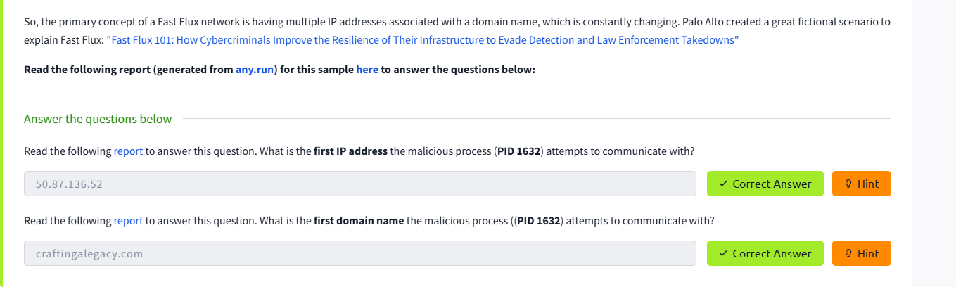

Domain Name (DN):

The domain name is actually mapped with the ip address. For example, an ip address is mapped with a string of text then it is called the domain.
The domain consists of a sub-domain and a top level domain for example evil.com is top-level domain and followed by a sub-domain (tryhackme.evil.corp)
Domain name little a more pain for the attacker because the need to purchase the domain , register it and modify DNS record Unfortunately for defenders, many DNS providers have loose standarads and provide API that make it eaiser to launch the attack.

The puny code is a concept that translate the domain names into the local language, which becomes computer friendly because the computer uses only the ASCII character.
Now this is a legitimate use but the hacker use this puny code technique to use the to make the similar domains names observer it from the screenshots: to run their phishing compains.

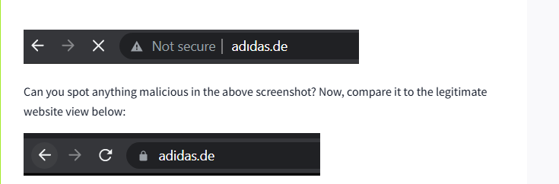

Now the explorations of the different tabs of the Any.run it is actually the a sandbox to observer the malware behaviour dynamically thanks.

Host Artifacts:

The host artifacts are the traces, observable that the attackers leave on the system. We analyze our system and identify the root cause of the attackers behavior it is very annoying for the attacker as we identified the IOC,s now its time for the attacker to developed the new tools.

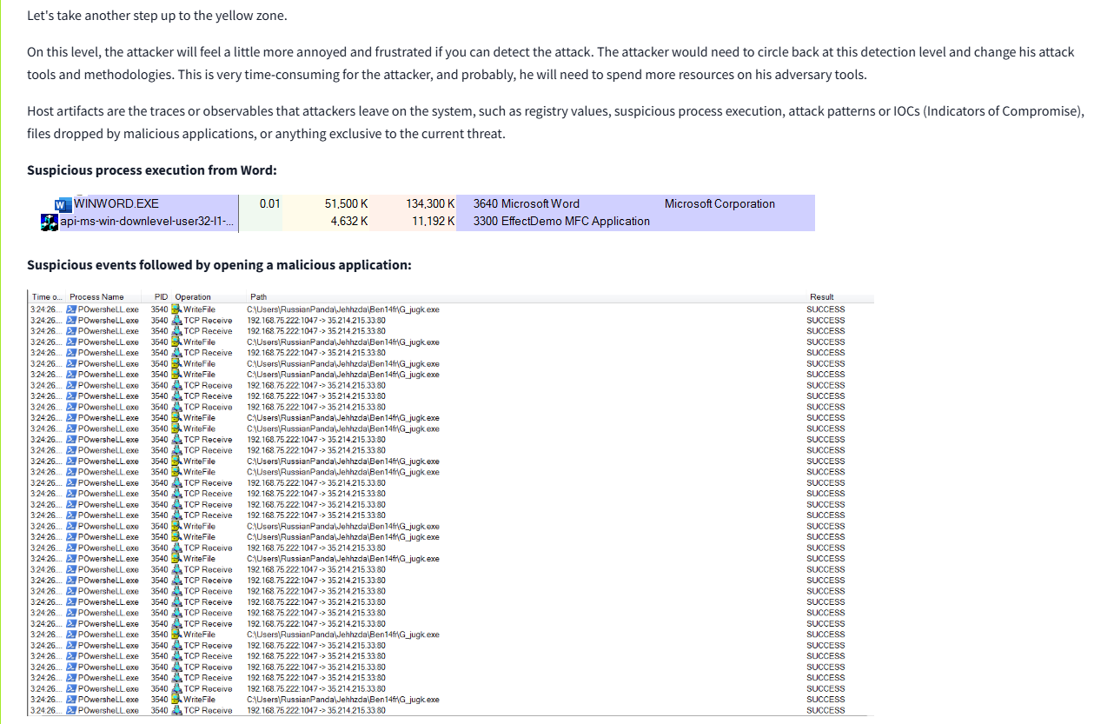

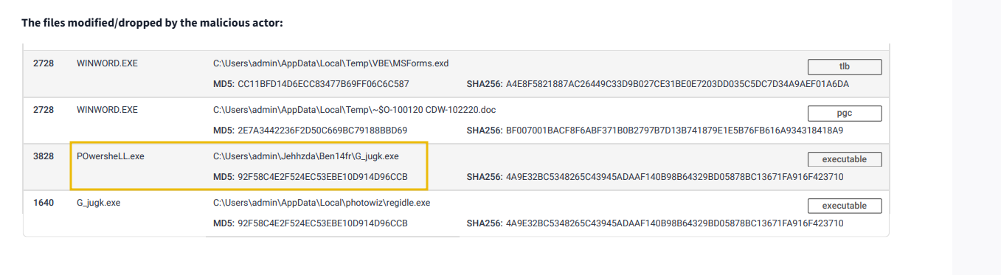

Network Artifacts:

In the network artifacts we need to detect and respond to user agent strings , C2 information and URL associated with the http post request followed by the attacker
That uses this technique to bypass the security environment. At this stage of network we respond to attacker and stop it so it becomes annoyed for it to change its strategies.

For this we used the network tools:

Wireshark PCAP analysis by using the T-shark analyzer and IDS i.e snort for detections.

Here’s a complete SOC interview Q&A set based on User-Agent, Network Artifacts, and detection techniques, with clear answers:

1️⃣ Conceptual / Theory Questions & Answers

Q1: What is a User-Agent in HTTP communication?
A: A User-Agent is an HTTP header field (defined in RFC 2616) that identifies the software making the HTTP request, such as a web browser, mobile app, or script.
It usually contains information like the browser name, version, and operating system (e.g., Mozilla/5.0 (Windows NT 10.0; Win64; x64)).

Q2: Which RFC defines the User-Agent header, and what is its purpose?
A: RFC 2616 defines the User-Agent header. Its purpose is to provide information about the client application (browser or tool) making the request, which servers can use for content optimization, debugging, or analytics.

Q3: Why would an attacker modify the User-Agent string in a malicious request?
A: Attackers may change the User-Agent to:
- Evade detection by pretending to be a legitimate browser or application.
- Identify themselves to their Command & Control (C2) servers.
- Exploit servers that treat certain User-Agents differently (e.g., mobile vs. desktop).

Q4: What are network artifacts, and why are they important in threat detection?
A: Network artifacts are pieces of network-related evidence generated by communication between systems.
Examples include:
- User-Agent strings
- C2 IP addresses/domains
- HTTP URI patterns
These artifacts help SOC analysts identify malicious activity and trace attacker behavior.

Q5: Explain how network artifacts fit into the Pyramid of Pain.
A: In the Pyramid of Pain, network artifacts belong to the yellow zone.
- If defenders detect and block artifacts (like a unique User-Agent or C2 domain), attackers must modify their tools or infrastructure to continue the attack.
- This creates friction and delays, buying the SOC team time to respond and remediate.

Q6: Why are network artifacts placed in the yellow zone?
A: Because they require the attacker to make moderate changes (like changing C2 servers or traffic patterns), which is harder than changing a simple hash but easier than changing their entire toolset.

Q7: How can unusual User-Agent strings help detect malicious activity?
A: A User-Agent string that:
- Has never been seen in the environment,
- Looks abnormal (e.g., random characters, missing OS/browser details),
- Mimics a legitimate browser but with small mistakes
can indicate custom malware, bots, or command-and-control traffic.

Q8: How can SOC analysts use IDS tools like Snort to detect network artifacts?
A: SOC analysts can:
- Create Snort rules to trigger alerts when specific User-Agents, C2 domains, or URI patterns are detected in network traffic.
- Use signature-based or anomaly-based detection to flag deviations from normal traffic.

Q9: What is the significance of detecting HTTP POST requests in incident response?
A: Attackers often use HTTP POST to exfiltrate data or send commands to C2 servers.
Detecting suspicious POST requests can reveal:
- Data leaks,
- Malware callbacks,
- Ongoing intrusions.

2️⃣ Practical / Hands-On Questions & Answers

Q10: How would you use Wireshark to identify suspicious HTTP traffic?
A:
- Open the PCAP file in Wireshark.
- Apply filters like:
- http.request
or
http.user_agent contains "suspicious_string"
- Inspect HTTP headers, User-Agent strings, and POST requests for anomalies.

Q11: What does this TShark command do?
tshark --Y http.request -T fields -e http.host -e http.user_agent -r analysis_file.pcap
A:
- --Y http.request: Filters only HTTP request packets.
- -T fields: Extracts specific fields instead of full packets.
- -e http.host: Shows the requested host.
- -e http.user_agent: Shows the User-Agent string.
- -r analysis_file.pcap: Reads from the given PCAP file.
➡️ In short, this command lists all hostnames and their User-Agent strings found in the PCAP.

Q12: If you find an unusual User-Agent in a PCAP file, what steps would you take next?
A:
- Verify legitimacy: Compare with known User-Agent databases (e.g., browser signatures).
- Correlate: Check logs (firewall, IDS, proxy) for related IPs/domains.
- Contain: Block suspicious domains or IPs if malicious.
- Escalate: Alert the SOC incident response team for further investigation.

Q13: Once a suspicious User-Agent is identified, what are the immediate SOC actions?
A:
- Investigate associated traffic (source IP, destination IP, timestamps).
- Check if it is communicating with known malicious domains (via Threat Intelligence).
- Block or isolate affected hosts if malicious activity is confirmed.

3️⃣ Scenario-Based Questions & Answers

Q14: You detect an HTTP POST request with a never-before-seen User-Agent. How would you respond?
A:
- Inspect the request: Look for payload data and destination.
- Query Threat Intel: Check if the IP or domain is malicious.
- Monitor the source host: Capture live network traffic for further analysis.
- Contain & Remediate: Block C2 communication, isolate host, and perform malware analysis.

Q15: An attacker keeps rotating their User-Agent to avoid detection. How would you detect them?
A:
- Look for behavioral patterns instead of static strings (e.g., unusual request frequency, time-of-day patterns).
- Use TLS fingerprinting (JA3), URI patterns, or IP reputation.
- Deploy machine learning or anomaly-based detection to spot traffic irregularities.

⚡ Quick Takeaways
Topic | Key Point
User-Agent | Identifies client software (browser/app) in HTTP requests.
RFC | Defined in RFC 2616 (HTTP/1.1).
Network Artifacts | Evidence like User-Agent strings, C2 IPs, or URI patterns.
Pyramid of Pain Zone | Yellow zone—moderate difficulty for attackers to change.
Detection Tools | Wireshark, TShark, Snort, Suricata.

Would you like me to also include sample Snort rules for detecting suspicious User-Agent strings (often asked in SOC practical interviews)?

Tools:

The strategies that the attacker used for spear phishing they developed the maldocs.
And also backdoor that can established the C2, any custom EXE , and .DLL files, payloads, or passwords crackers.

A trojan drops the suspicious files in the tmp folder of the window.
The malware bazaar and the mal-share are the platforms that can provides us the great information about the IoC or trending threats.

Now we can use the tools like the YARA, IDS, IPS and other to create the rules against these malwares.
For the rules we have a platforms that can be gives us the set of rules SoC prime detections.

And also, a concept of fuzzy hashing like us the ability to perform the similarity analysis.
Another name of fuzzy hashing is context triggered piecewise hashes.

Here’s a deep SOC-level breakdown of where different types of malware (from simple keyloggers to advanced BIOS/rootkits) drop their files on Windows and Linux/Enterprise servers, along with severity, detection difficulty, and tools for SOC analysis:

1️⃣ Where Malware Drops Files – Windows
Location | Typical Malware Type | Purpose | Severity | Detection Difficulty
%TEMP% or %TMP% (e.g., C:\Users\<User>\AppData\Local\Temp) | Droppers, Trojans, Ransomware, Keyloggers | Temporary staging area before moving to persistence location | Medium – Common for legitimate software | Easy to Moderate (EDR/AV can catch, but needs monitoring for unusual executables)
%APPDATA% / %LOCALAPPDATA% | Info-stealers, RATs (e.g., Emotet, LokiBot) | User-level persistence (no admin rights needed) | High | Moderate (blend with normal user files)
%PROGRAMDATA% | RATs, Keyloggers, Spyware | System-wide persistence, hidden from casual users | High | Harder than AppData; requires admin privileges
%SYSTEMROOT%\System32 or SysWOW64 | Rootkits, Advanced Trojans | Direct execution with SYSTEM privileges | Critical | High – attackers use file names similar to system files (e.g., svchost.exe)
Registry Run Keys (HKCU\Software\Microsoft\Windows\CurrentVersion\Run) | Adware, Keyloggers | Auto-start on boot | High | Moderate (detected by EDR/registry monitoring)
Windows Services (services.msc) | Persistent Trojans, Ransomware | Create malicious services to survive reboots | Critical | High
Scheduled Tasks (%WINDIR%\System32\Tasks) | RATs, Ransomware | Timed persistence | High | High if well obfuscated
Boot Sector / MBR (Master Boot Record) | Bootkits, Ransomware (Petya) | Pre-OS execution | Critical | Very Hard (requires forensic tools)
UEFI/BIOS Firmware | Firmware Rootkits (LoJax, MoonBounce) | Survives OS reinstallation | Severe/Catastrophic | Extremely Hard (requires hardware forensics)
WMI Event Subscriptions | Fileless malware (APT29) | Memory-resident persistence | High | High (stealthy, no file drop)

2️⃣ Where Malware Drops Files – Linux/Enterprise
Location | Typical Malware Type | Purpose | Severity | Detection Difficulty
/tmp | Cryptominers, Trojans, RATs | Temporary storage for payloads, staging for privilege escalation | Medium | Easy to Moderate (but often ignored by admins)
/var/tmp | Worms, Backdoors | Survives reboots (unlike /tmp) | High | Moderate
/dev/shm (Shared Memory) | Fileless malware, Cryptominers | In-memory execution | High | Hard (no on-disk evidence)
User Home Directories (~/.config, ~/.local) | RATs, Info-stealers | User-level persistence | High | Moderate
/etc/cron.* or Crontab | Rootkits, Backdoors | Scheduled persistence | Critical | High
/lib, /usr/lib | Rootkits (LD_PRELOAD) | Library hijacking | Critical | High
Kernel Modules (/lib/modules) | Rootkits (Loadable Kernel Modules) | Kernel-level persistence | Critical | Very Hard
Bootloader (/boot, GRUB, EFI firmware) | Firmware Rootkits | Survive OS reinstall | Severe/Catastrophic | Extremely Hard

3️⃣ Severity Mapping
Severity depends on depth of persistence:
Persistence Depth | Examples | Severity | Why
User Temp Folders | %TEMP%, /tmp | 🔵 Medium | Easy to remove; mostly staging
User-Level Persistence | AppData, ~/.config | 🟠 High | Survives reboots, can exfiltrate data
System-Level Persistence | System32, /usr/lib, Services | 🔴 Critical | Full system compromise
Boot/Kernel/Firmware | MBR, UEFI, Kernel Modules | ⚫ Catastrophic | Survives OS reinstalls; requires hardware reflash

4️⃣ Detection Difficulty
Category | Difficulty | Reason
Temp/Transient Files | Easy → Moderate | Tools like AV/EDR can catch; signature-based
User Persistence (AppData, ~/.config) | Moderate | Blends with legitimate user data
System Persistence (System32, /usr/lib) | High | Requires root/admin; attackers use mimicry
Firmware/Bootkits | Extreme | Below OS level; needs firmware analysis tools

5️⃣ Tools for SOC Analysts

Windows
- EDR/XDR:
CrowdStrike, SentinelOne, Microsoft Defender for Endpoint → detect file drops, registry changes.
- Forensics:
  - Sysinternals Suite (Autoruns, Process Explorer, Procmon) → detect hidden startups.
  - Volatility → memory forensics.
  - FTK Imager → disk analysis.
- Network:
Wireshark, Zeek (Bro), Suricata for PCAP inspection.

Linux/Enterprise
- File Integrity Monitoring (FIM):
OSSEC/Wazuh, Tripwire → detect unauthorized file changes.
- Process/Kernel Analysis:
chkrootkit, rkhunter, auditd → find hidden rootkits.
- Memory Forensics:
LiME + Volatility → detect in-memory malware.
- Network Monitoring:
Zeek, Suricata, TShark for C2 detection.

Cross-Platform
- SIEM Platforms:
Splunk, ELK Stack, QRadar → centralize logs & detect anomalies.
- Threat Intel:
VirusTotal, Hybrid Analysis, Any.Run for suspicious files.

6️⃣ SOC Workflow for Detection
- Ingest Logs – Windows Event Logs, Linux syslog, IDS/IPS alerts.
- Correlate – Look for suspicious temp file creation, unusual binaries in system directories, new services, or startup items.
- Hunt for Persistence – Scheduled tasks, cron jobs, WMI subscriptions, autoruns.
- Analyze Network Traffic – Detect C2 patterns, exfiltration attempts.
- Forensic Deep Dive – Memory analysis for fileless attacks.

⚠️ Key Takeaways for a SOC Analyst
- A drop in %TEMP% or /tmp is Medium severity (common but worth investigating).
- A drop in system folders or boot sectors is Critical to Catastrophic (high priority, immediate response).
- Firmware/UEFI infections are the hardest to detect and require special hardware tools and firmware reflash to remediate.
- Best Defense:
  - Continuous EDR/Threat Hunting.
  - Behavior-based detection (MITRE ATT&CK mapping).
  - Regular file integrity checks and network anomaly monitoring.

TTPS:
Tactics, Techniques and Procedures are very important, first of all understand these can help us to mitigate the threat and the MITRE-attack framework can help us to understand the behaviors about the adversaries. So, we can mitigate it from phishing mails to persistence and data exfiltration’s.

